Republic of the Philippines

**CAVITE** **STATE** **UNIVERSITY**

**Silang** **Campus**

Biga I, Silang, Cavite

*046* *513-5706* *046* *513-3965*

✉ cvsusilang@cvsu.edu.ph

**DEPARTMENT** **OF** **INFORMATION** **TECHNOLOGY**

**First Semester, AY 2021-2022**

**Project Proposal in**

**DCIT 50 – Object Oriented Programming**

**Le Classique Beauté Collectif**

**Inventory and Point of Sale System**

**Submitted by:**

Deocampo, Angel Mae C.

Gatpandan, Nathaniel M.

Salazar, Ana Bien Beatriz, G.

**Submitted to:**

Anciro, Eleandro C.

**Le Classique Beauté Collectif**

**Inventory and Point of Sale System**

**Project Description**

An inventory system is important because it makes it easier to keep track of and manage a store's inventory of supplies and merchandise. By minimizing excess inventory, which can squander precious financial resources, it helps to ensure that there are enough product quantities available to meet customer demand. When it comes to the point-of-sale system, it enables quicker checkouts, which can enhance the customer experience and shorten wait times and inventory levels can be updated automatically by POS systems, simplifying stock tracking and management.

The brief details process of developing this system:

* Determine the features for the inventory and POS system.
* Develop the inventory system and incorporate the POS system.
* Include the hardware integration of the system. i.e., a thermal printer.
* Check for possible issues and test the system.

**Why are POS and inventory necessary in today's use?**

* **Comprehensive and efficient record keeping:** An inventory and point of sale system enables real-time tracking of inventory levels, sales statistics, and customer information.
* **Improved customer service:** An inventory and point of sale system can help small businesses in offering individualized and effective assistance to their clients by enabling quick and easy access to customer information and purchase history.
* **Reduced risk of errors and losses resulting from human error:** small businesses can lower their risk of errors and losses by automating the process of tracking inventory and sales.

**Le Classique Beauté Collectif**

**Inventory and Point of Sale System**

**Advantages of the Project**

* **Local database:** Many inventories and point-of-sale systems are still local-based, meaning that they are accessed and managed through the local area network.
* **Real-time inventory tracking:** Modern POS systems could track inventory in real-time, giving customers a current picture of what is available and what needs to be refilled.
* **Better visibility:** Real-time data on sales and inventory levels are simple to obtain with an inventory and POS system.

**Scope, limitations, and delimitations**

**Scope:**

* The system will be restricted to a single physical location, such a pharmacy or retail shop.
* Monitors sales transactions and track inventory.
* Generates reports on inventory and sales levels.
* Supports the development of new items as well as the modification of current ones.
* Sales receipts and transactions will be produced by the system.
* Monitoring consumer data and past purchases.

**Limitations:**

* Personnel working at the physical place are the only person to handle access to the system.
* The system will not be capable of handling transactions from various places or online sales.
* The software or hardware availability at the physical site may impose limits on the system.
* Only cash can be received into the system.

**Delimitations:**

* The system will only keep track of inventory for things that are kept on-site.
* Outside of the physical site, the system will not be able to connect to databases.
* The system will not have marketing or customer relationship management capabilities.
* The system will not perform any product reservations.
* Credit/debit card transactions and internet payments are not recognized by the system.
* Administrator and Staff roles will not be included in the system.
* returns and exchanges will not be included in the system.
* The industry or company that the system is aimed, such as a retail store or pharmacy.

**Le Classique Beauté Collectif**

**Inventory and Point of Sale System**

**The efficiency of the Project**

A local server for an inventory and point-of-sale system may be more effective and efficient than a cloud-based or remotely hosted solution for several reasons:

* **Faster performance:** When data is stored and processed locally rather than being transmitted over the internet, a local server can provide faster access to data and system resources.
* **Better managing:** A local server provides the business more authority over the software and hardware that are used, as well as the security and operation of the system.

When it comes to user friendliness. Our inventory and point-of-sale systems have an Y2K aesthetic interface to give the user an experience that exudes modernism and creativity and aesthetically appealing and fascinating. Additionally, it includes clear and logical procedures for completing tasks like making a transaction, replenishing inventory, and generating reports.

**Le Classique Beauté Collectif**

**Inventory and Point of Sale System**

**Project Manual**

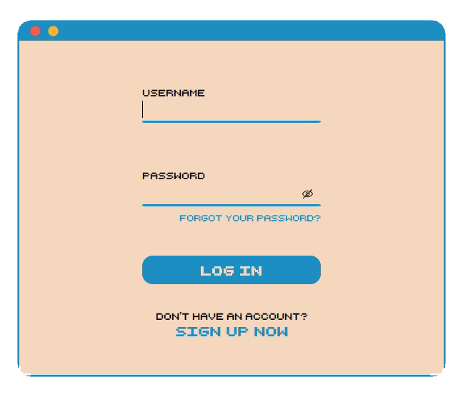

**Image 1: Log in Form**

To verify user identity and grant access to a system.

**Image 2: Sign up Form**

To create a new account and register user information.

**Image 3: Forgot Password Form**

To retrieve a forgotten password for an account.

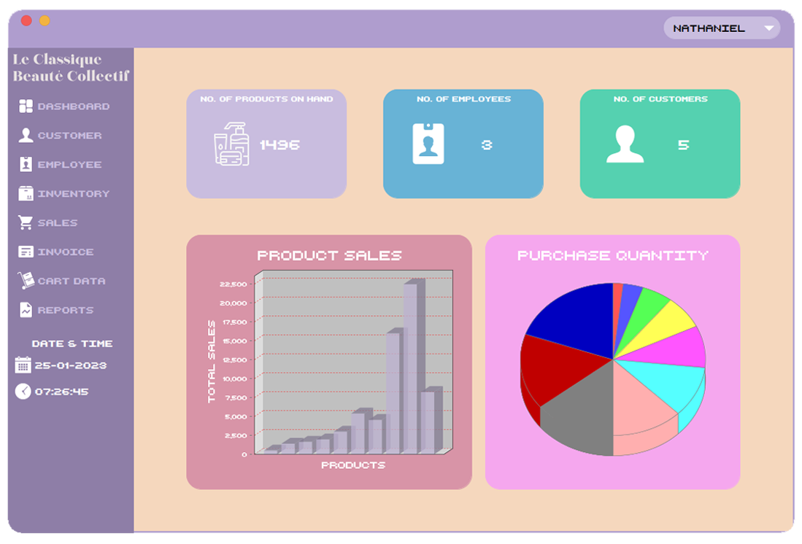

**Image 4: Main/Dashboard Panel**

To provide an overview and access to various features and tools.

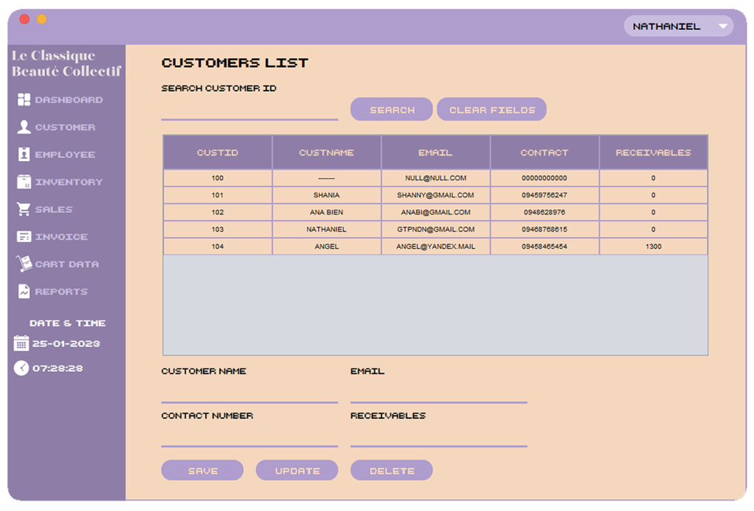

**Image 5: Customer Panel**

To view and modify customer information.

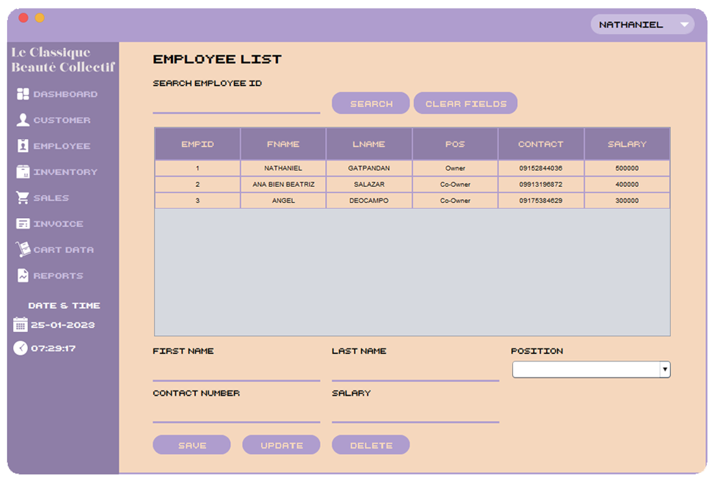

**Image 6: Employee Panel**

To view and modify employee information and work position.

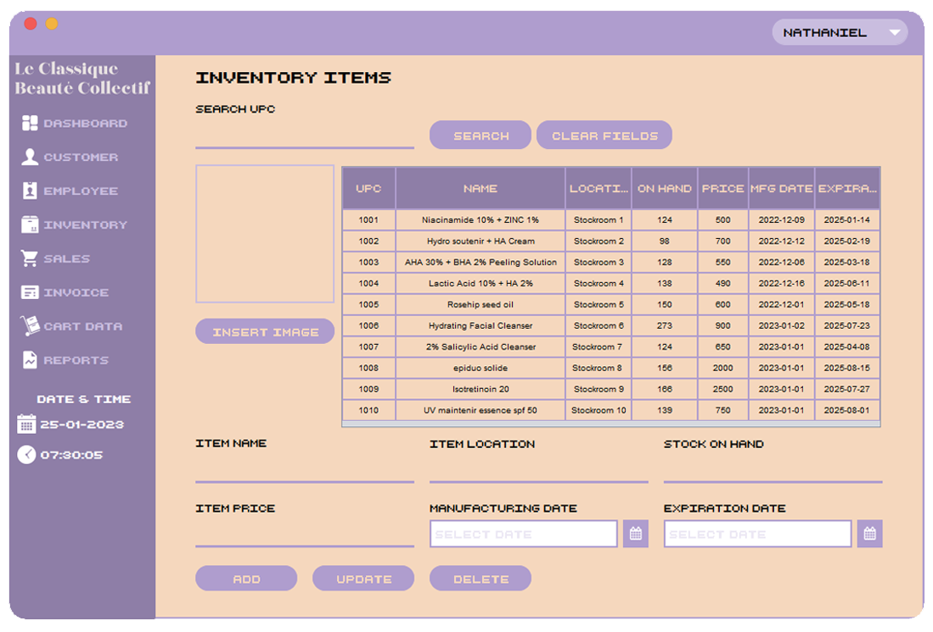

**Image 7: Inventory Panel**

To track and manage inventory levels and details. (Might to add another feature)

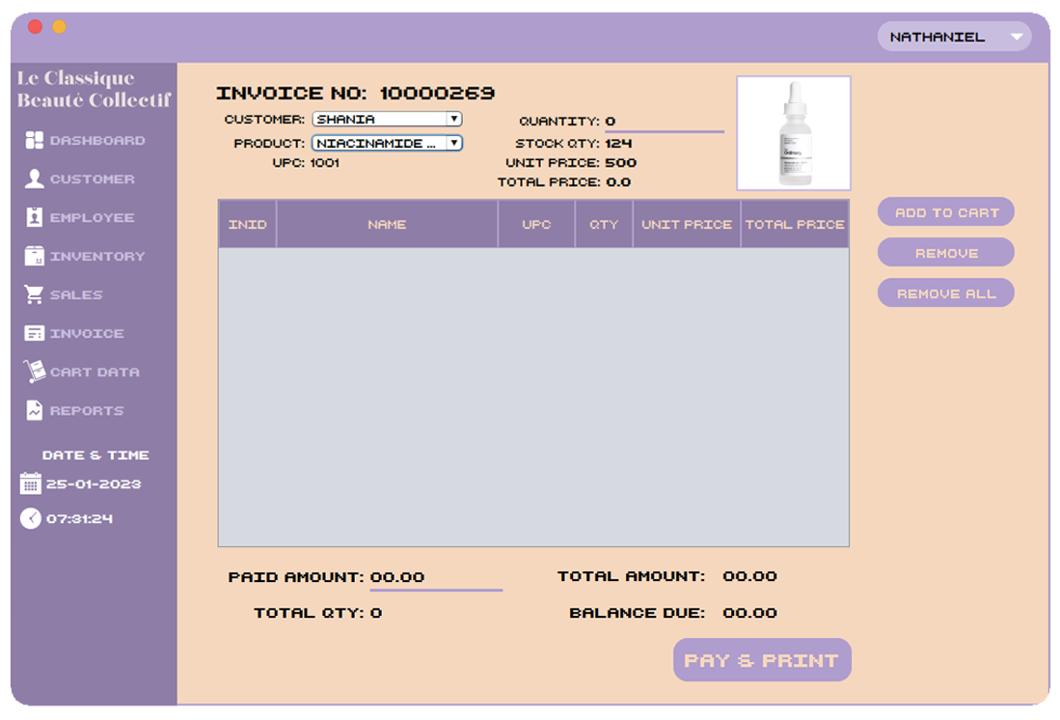

**Image 8: Sales Panel**

To process transactions and record sales data in real-time.

**Image 8.1: Sales Panel “Receipt”**

To confirm a transaction between a business and a customer.

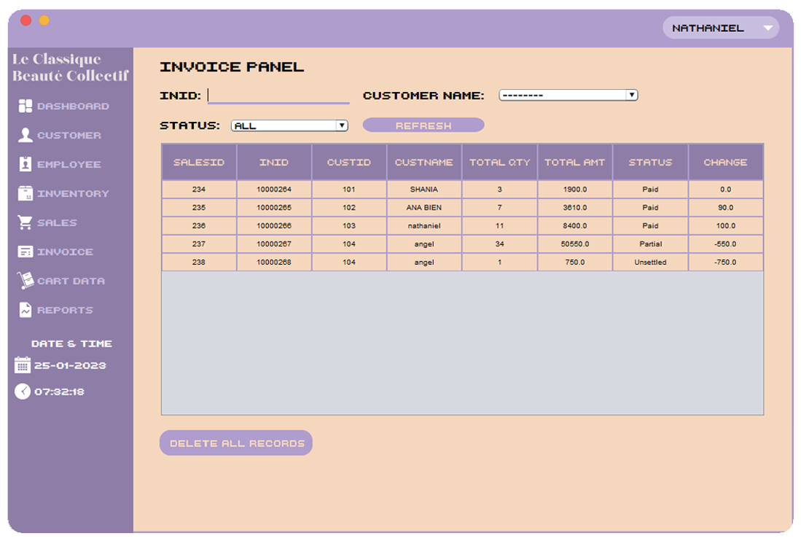

**Image 9: Invoice Panel**

To store invoices for customer payments.

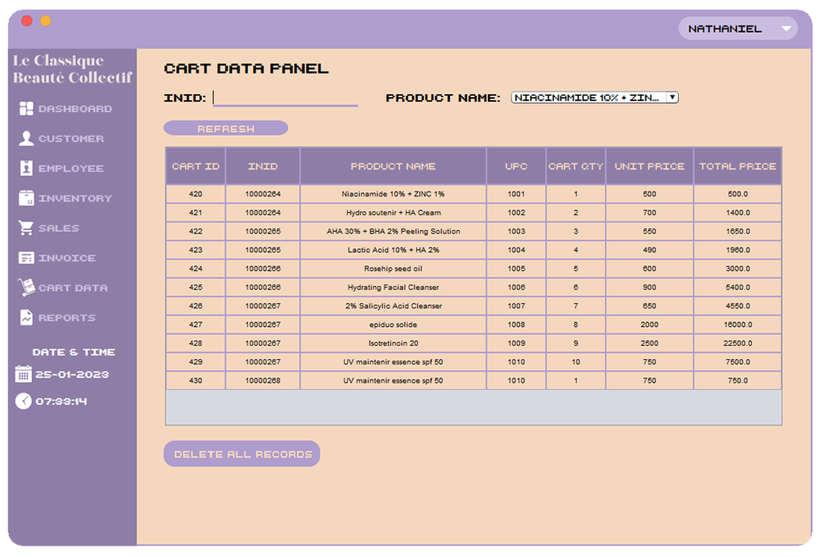

**Image 10: Cart Data Panel**

To store and delete what customer bought.

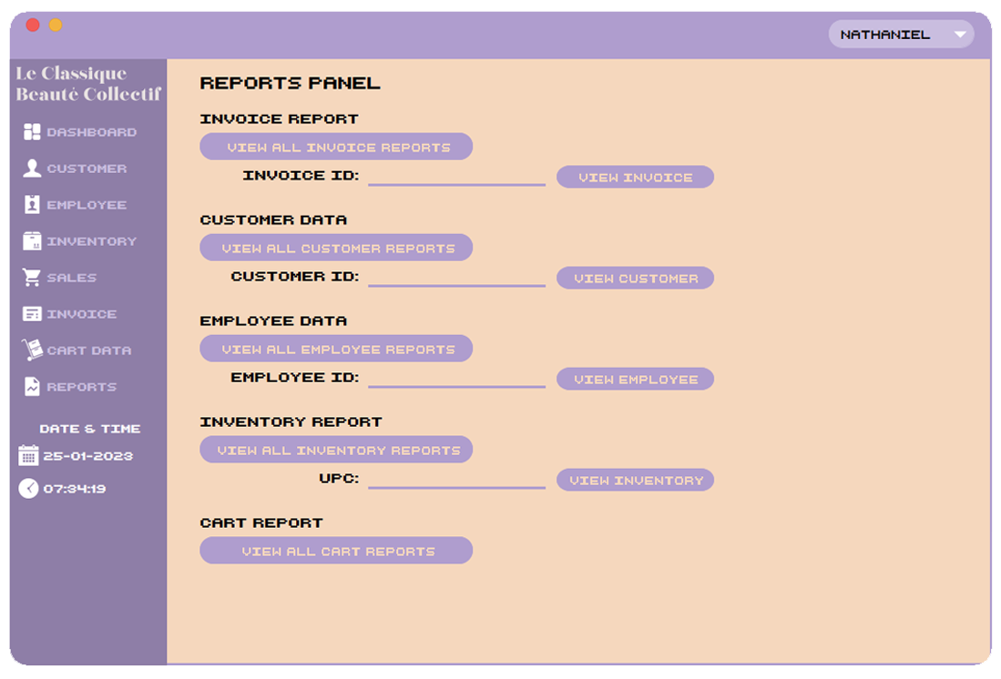

**Image 11: Reports Panel**

To generate and view detailed data and analysis.

**Image 12: Reports Panel “View All Invoice Reports”**

To view all the Invoice data report.

**Image 12.1: Reports Panel “View Invoice”**

To view the Invoice data report by specific Invoice ID.

**Image 13: Reports Panel “View All Customer Reports”**

To view all the Customer data reports.

**Image 13.1: Reports Panel “View Customer”**

To view the Customer data report by Customer name.

**Image 14: Reports Panel “View All Employee Reports”**

To view all the Employee data reports.

**Image 14.1: Reports Panel “View Employee”**

To view the Invoice data report by specific employee ID.

**Image 15: Reports Panel “View All Inventory Reports”**

To view all the Inventory data reports.

**Image 15.1: Reports Panel “View Inventory”**

To view the Inventory data report by specific UPC (Universal Product Code)

**Image 16: Reports Panel “View All Cart Reports”**

To view all the Cart data reports.